Institute of social sciences and humanities – Skopje

School for politics and critique 2016
“Regional Political Forum on Marxist Theory and Practice in the Southeast Europe”

Lecturers: Silvia Federici, Santiago Zabala, Gal Kirn
24rD – 27th June 2016, Ohrid (Macedonia)

Application Form
* Please note that the number of positions is limited to 12 regional and 13 local participants.

1. PERSONAL DATA
Family name:
First name:
Date of birth:
Academic degree: (opt)
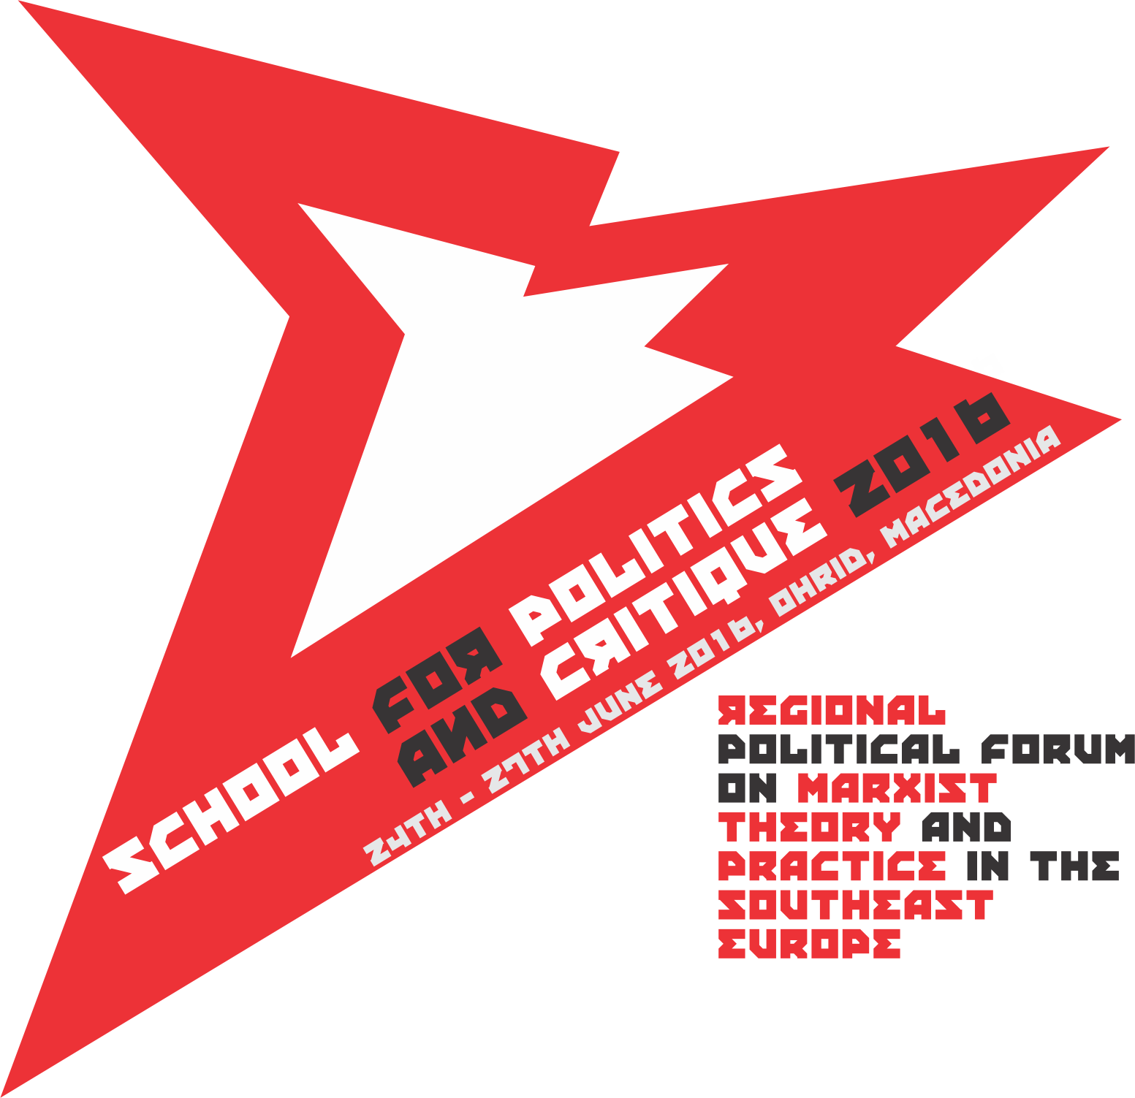
Citizenship:
Organization membership/affiliation: (opt)

2. PROFESSIONAL/ACADEMIC DATA
University/Institution:
Faculty:
Department:

Areas of Specialization:
Status (Employee/Student):
Position:

3. POLITICAL/ ACTIVIST DATA
Organization/ non-formal / movement:
Area(s) of activity:
Regional scope:
Period of activity:
Issues of political interest:

4. What are your expectations from the 2016 School for politics and critique of the ISSH-Skopje?

5. Please indicate the motivation for attending the 2016 School for politics and critique and how it is connected with your research interest or political activity in general (max. 200 words):

6. Feel free to attach a CV or list of articles you have written (opt)

Please return this application through e-mail to:
info@isshs.edu.mk

The deadline for sending the applications for the 2016 School for politics and critique is 30th of April 2016.

Contact details:
Address:
Phone:
E-mail:

